**Context dependent selection as the keystone in the somatic evolution of cancer**

Abstract:

Somatic evolution of cancer involves a series of mutations and accompanying genomic, epigenomic and physiological changes in one or more clones of cells. Whether the mutations accumulate by chance alone (bad luck hypothesis) or owing to selection of intermediate mutants leading to clonal expansion is an unresolved question. An implicit assumption in clonal expansion is that any mutation leading to partial loss of regulation of cell proliferation will give a selective advantage to the mutant. However, a number of experiments show that an intermediate precancer mutant has only a conditional selective advantage. Accordingly the selective advantage to a mutant will be different in every individual depending upon the genetic, developmental, dietary, behavioural, habitual and physiological background. Thus the selective advantage to a mutant will be widely distributed across individuals in the population. We comparatively evaluate the three models namely bad luck, context independent selection and context dependent selection with respect to their ability to predict patterns in total incidence, age specific incidence, tissue specific incidence and their ability to explain Peto’s paradox and related paradoxes. Results show that context dependence is necessary and sufficient to explain all the observed patterns whereas the number of cells and mutation rates are not necessarily rate limiting. This implies that the susceptibility to cancer can be substantially different across individuals and cancer is not sheer bad luck. This has important implications for the prevention of cancer by identifying and targeting the micro-environmental factors that influence the dynamics of selection.

**Context dependent selection as the keystone in the somatic evolution of cancer**

An old debate in the theory of evolution is how the simple process of random mutations and natural selection can lead to complex structures such as the eye that needs coordinated action of several genes. This problem is often perceived as a monkey on a typewriter paradox (1-4). How probable it is that a monkey sitting on a typewriter and hitting keys at random would end up typing a meaningful sentence? The problem of cancer is qualitatively similar to this but quantitatively even more difficult. No single mutation is known to make a cell cancerous. All cancers are necessarily a combination of different types of genomic changes including point mutations, aneuploidy and other chromosomal aberrations. The cancer phenotype has a large number of distinguishing characters that include independence from growth factor signalling, insensitivity to growth suppressing signals, evading apoptosis, telomere maintenance, sustained angiogenesis, evasion of contact inhibition, genomic instability, inflammation, altered glucose metabolism, co-option of other cell types, tissue invasion and metastasis (5). It is astonishing that so many alterations in cell properties come together in cancers. Moreover, cancer has to evolve independently in each individual suffering from it. Since mutation accumulation is recognized to be central to carcinogenesis, increased rate of mutagenesis is said to be responsible for carcinogenesis.

A population level process implicated in carcinogenesis is clonal expansion. After every component mutation in the cancer process the mutant clone expands and as the mutant population increases, the probability of second component mutation increases proportionately. Implicit in this theory is the assumption that every component mutation has a selective advantage over the normal cell. Since most changes involved in carcinogenesis are about evading the growth regulation mechanisms, it is considered logical that any such mutant will have a selective advantage within a tissue.

However, not all experiments support the view that cells with component mutations are always at an advantage. ------. It is possible therefore that the fitness advantage to a mutant is largely dependent on the tissue microenvironment and therefore selective forces can vary considerably across different individuals.

We examine the three models namely (i) chance accumulation of mutations or the bad luck hypothesis, (ii) unconditional or context independent clonal selection and (iii) context dependent clonal selection to see whether they predict the epidemiological picture of cancer observed in human population. In addition we will also examine how the different models possibly explain the well-known Peto’s paradox (6-9), the red cell paradox () and the observed relationships with stem cell number () and mutation rates ().

It is also important that while undergoing a series of genomic alterations, the cell should not experience a lethal or deleterious mutation. Since a greater proportion of mutations would be deleterious to the cell, it is highly unlikely that a cell would acquire the specific combination of alterations that make it neoplastic without undergoing any deleterious mutation. In addition an evolving cancer cell would also be subject to Muller’s ratchet and thereby progressively reduce its fitness. We examine how the three models can incorporate these phenomenon.

**A. The bad luck model**: This hypothesis assumes that the set of driver mutations accumulate in a cell by chance alone. This may happen over a time course or in one go as in chromothripsis.

Consider an organism with a population of ‘n’ stem cells, each with a mutation rate per generation per genome, ‘p’. The probability that at least one cell acquires one mutation at a given point of time can be given as 1-(1-p)^n. If ‘k’ such mutations are required for caner onset, the probability of cancer, according to bad luck model, can be expressed as (1-(1-p)^n)^k [ref-algebraic model]. For the sake of simplicity, we have ignored the cost of lethal and/or passenger mutations; although they change some of the predictions for some model variables, we see that our inferences are largely unaffected by this assumption (SI-including lethal mutations in bad luck). On the whole, the algebraic form of the bad luck model predicts a strong threshold relationship of the probability of cancer with both cell number and mutation rate (Fig 1). For suitably large values of ‘n’ and ‘p’, ‘pmut’ increases to one rapidly, and this increase is more rapid when the number of required mutations for cancer is larger. Although this prediction can be understood in terms of the second equation above, it is clear from epidemiological data that it does not hold water as cancer risk does not have such threshold relationships with mutation rate and cell number [ref and figures]. Moreover, this model does not include time-dependent factors that affect mutation accumulation. The quantity, ‘pmut’ is not time-dependent, in that it is the same at every point over the lifespan of the organism, as the basal mutation rates and cell numbers do not change for a given organism over extended periods of time in a deterministic way following well-understood phenomena. In that sense, ‘pmut’ is the mutation accumulation probability per cell divison, and the probability of cancer summed over the lifetime of an organism would simply be the cumulative sum of this constant instantaneous mutation accumulation rate. This cumulative probability would exceed one very quickly when ‘pmut’ is greater than zero, and would never increase when ‘pmut’=0. At the population level, this leads to a very strong threshold of cancer incidence; either the entire population acquires all the oncogenic mutations (when ‘pmut’>0), or the entire population remains cancer-free (‘pmut’=0).

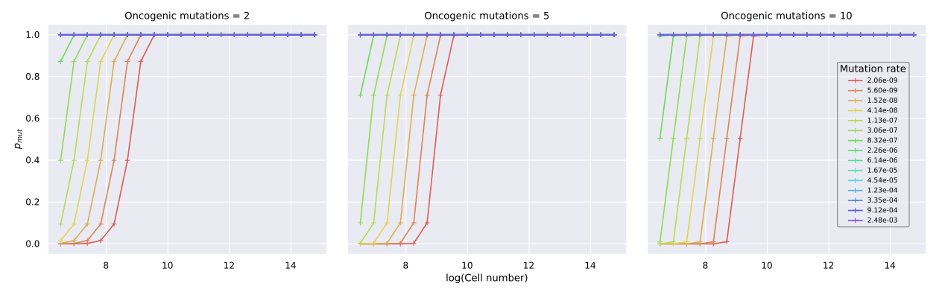Figure 1: Algebraic form of the bad luck model-predictions for ‘p’ and ‘n’; threshold relationship with ‘p’ and ‘n’ seemingly gets stronger for larger numbers of required mutations for cancer.

As phenomenological models that led to the multi-stage hypothesis, the equations from Nordling, Armitage-Doll and many others since [ref], can be used to describe the temporal dynamics of mutation accumulation more realistically, as they include time explicitly as an independent variable. It is well-known that this class of empirical models predicts a power law relationship of mutation accumulation probability with age (time), in which probability of cancer increases exponentially with age. However, it is being recognised for some time now that cancer incidence itself does not increase as monotonously, and the pronounced decrease in late-life incidence of cancer seems like it is here to stay even after accounting for various demographic biases and risk factors [ref]. This inconsistency remains to be reconciled, although attempts to evaluate alternative models comparatively have been sparse.

Fundamentally, Armitage-Doll and other statistical models are empirically-derived, and therefore rely on stochastic processes whose average behaviour can be described. It is this property that leads to include this class of models in the “bad luck” category, as their predictions do not involve other deterministic factors.

The bad luck model predicts a threshold relationship with both mutation rate and cell number at the level of an organism, and predicts a binary outcome for cancer onset at the population level, where either all organisms accumulate all the oncogenic mutations, or none at all. Taken together, regardless of whether accumulation of oncogenic mutations is instantaneous or distributed in time, bad luck or random chance is an insufficient explanation for mutagenesis in cancer, in terms of total incidence, age dependence, and the effect of the mutation rate and cell number.

**B: The context-independent selection model**:

We noted earlier that the bad luck model does not include any time-variant factors in its explanation of mutation accumulation. The multi-stage hypothesis of carcinogenesis introduced the idea of clonal expansion, by which a mutation provides a selective advantage to the cell, and the mutant cell grows and competitively excludes non-mutant cells. As with cell growth in general, clonal expansion of mutants is a time course-dependent process, and the accumulation of subsequent mutations is determined to a large extent by the selective advantage of the previous mutation. To some extent, deterministic multi-stage models by Frank [ref] have incorporated the effect of clonal expansion on cancer progression, but these models nevertheless do not provide simple access to parameters of progression like the mutation rate and cell number. We therefore explore these parameters using a simulation model instead.

We begin by considering an organism starting from one stem cell with a mutation rate per divison per genome, ‘p’, growing logistically to a carrying capacity of ‘n’, following the equation below:

m(i, t) = m(i, t-1)*g(i)*(n – Σm)/n,

where, m(i, t) = size of the ‘i’th mutant population, with i = 0 being the non-mutant cell population,

g(i) = growth rate of the ‘i’the cell population,

Σm = sum of m(i), for i = 0, ..., threshold, and

threshold refers to the number of oncogenic mutations required for cancer onset. This is set to 5 arbitrarily in all further simulations.

As the equation above shows, growth of every cell population is regulated by its own population size, and that of the other mutants or non-mutants in the system. Based on a development time of roughly ten years, we estimate the non-mutant growth rate, g(0) to be 0.007, and use this to standardize the time scale of the logistic growth process (SI). This leads to each step of logistic growth being equivalent to one day, with a lifespan of 100 years. For a given cell population, the probability that at least one cell acquires a mutation is given by 1-(1-p)^m(i), where ‘i’ is the index of the most recent cell population. Mutation events are simulated in the most recent cell population stochastically; if the above probability exceeds a randomly generated number between 0 and 1, a mutation event is considered to have occurred, m(i+1, t) is set to one, and m(i, t) is reduced by one. The mutation probability then tracks m(i+1) in time for the next mutation. This model therefore describes a linear form of somatic evolution in which pre-oncogenic cells accumulate mutations sequentially interspersed by periods of clonal expansion, with only one lineage evolving at any given point of time [ref]. This simulation is carried out for a population of 10,000 organisms, and organism death in the simulation occurs either at the end of the stipulated 100-year lifespan, or upon accumulation of all five oncogenic mutations. This model can then be used to get a count of cancer onset in the population against age, which enables comparison of age-related predictions across the different models.

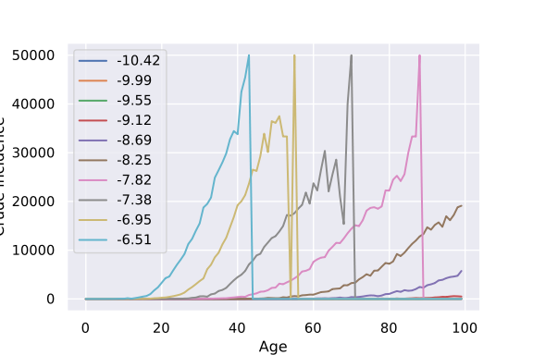Oncogenicity of a mutation is defined based on the logistic growth rate associated with it, as the growth rate drives the accumulation of the next mutation through clonal expansion. Starting from 0.007 for the non-mutant cells, growth rate increases linearly with each subsequent mutation in multiples of 0.007. In the absence of hard data on trends in the selective advantages of oncogenic mutations, a linearly-increasing advantage seems like an intuitive assumption to make, and slightly different trends in the growth rate still produce qualitatively similar predictions. For the context-independent model, this progression in mutant growth rates remains the same for all organisms in the population.

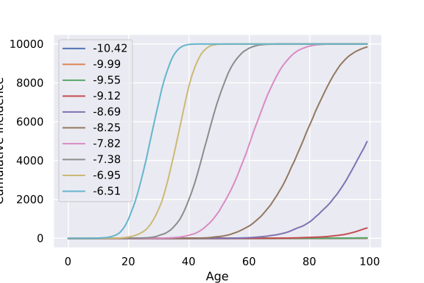

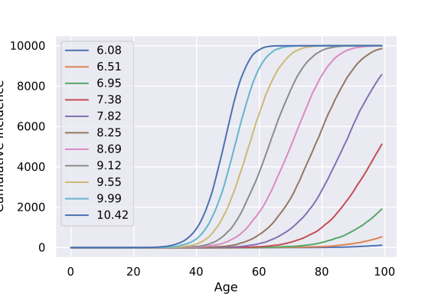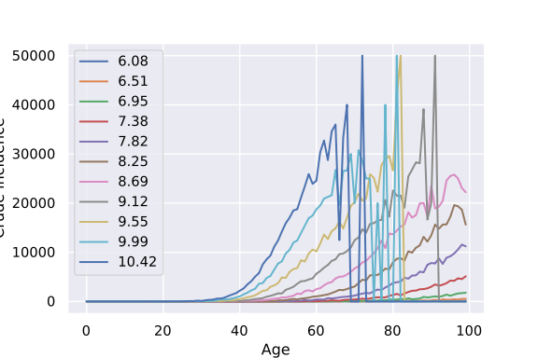

Fig 2: Cumulative incidence, and crude incidence per 100,000 for the context-independent model, as a function of mutation rate and cell number (log10 values in the corresponding legends).

The first point of divergence of the context-independent model is that the total probability of cancer, as estimated from the maximum cumulative incidence can lie in the realistic range of between 20 and 30% for sufficiently small values of ‘p’ and ‘n’. This temporal pattern in progression arises from the clonal expansion of intermediate mutants on the way to cancer onset. The acquisition of the next mutation is limited strongly by the expansion of the previous mutation, which in turn is a function of the selection acting on it as given by the progression of growth rates across mutations within an organism. However, the predicted cancer probability is realistic only in the lower end of the parameter space of ‘p’ and ‘n’, and in the higher end of the ranges of both parameters, the context-independent model predicts 100% cancer incidence. By extension, it can be seen that the lower incidence predicted for lower values of ‘p’ and ‘n’ is only an effect of the limitation of time. Given enough time, the cumulative incidence curves rises to 100%, albeit at lower rates, in the lower range of ‘p’ and ‘n’. This is because all organisms in the population share the same growth rate progression for mutants, and accumulation of mutations is therefore identical across the entire population. No other parameter in the model precludes the accumulation of all five oncogenic mutations in some organisms, and the dynamics of accumulation is entirely a function of ‘p’ and ‘n’.

The simulation model framework so far has shown that while clonal expansion can produce some realistic predictions of cancer incidence, its explanation of cancer progression and mutation accumulation is inherently incomplete, and produces several inconsistencies with observed trends, including the late-life decline in cancer incidence noted earlier.

**C: The context-dependent selection model**:

The bad luck model dealt with parameters at the level of the genome and the cell, while clonal expansion in the context-independent model extended the picture to competitive progression of cancer at the organismal level. A possible addition to this framework could be at the population level, in terms of heterogeneity among organisms in susceptability to cancer progression. There are sufficient indications from empirical observations that such heterogeneity is a normal feature in populations of organisms; selection on identical mutants is not identical acorss organisms, and can instead stem from various micro- and macro-environmental factors. This context dependence of the selection on somatic mutations can be captured through the slope of the linear progression of growth rates of mutants within an organism; low slope leads to slow clonal expansion, while a steep slope of progression leads to rapid clonal expansion. This slope then becomes an indicator of the susceptibility of that organism to accumulate the requried number of oncogenic mutations. To that end, we randomize the slope of the growth rate progression, while keeping the growth rate of the non-mutant cell population constant.

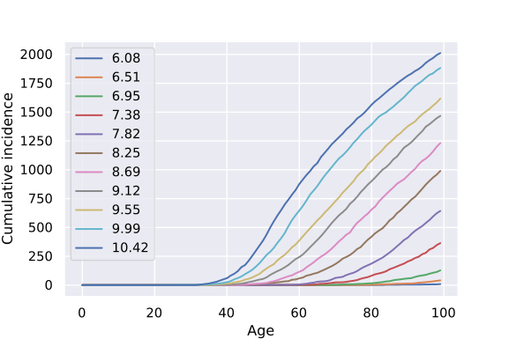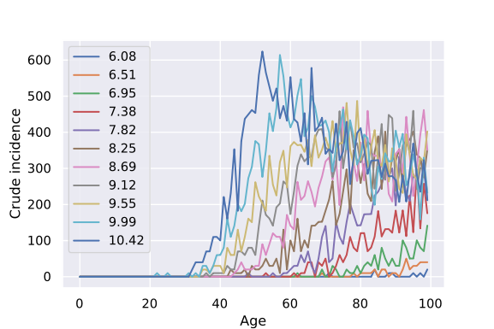

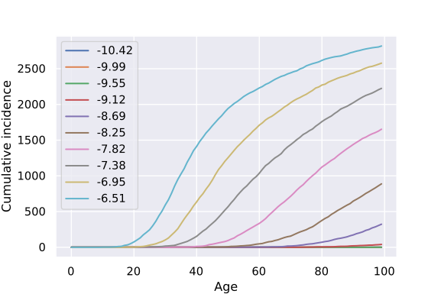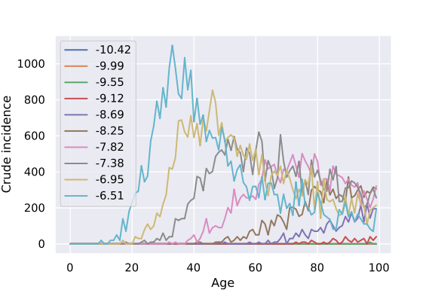

Fig 3: Cumulative incidence, and crude incidence per 100,000 for the context-dependent model, as a function of mutation rate and cell number (log10 values in the corresponding legends). Note that cancer onset is spread across all age groups, and shows distinct declines in late life stages, as opposed to the context-independent model, in which cancer onset increases up to a partciular age as a function of ‘p’ and ‘n’, and then drops sharply to zero beyond that age.

As opposed to the context-independent model, the context-dependent model produces a saturating trend in cumulative incidence that begins to saturate much lower than 100%. As Fig 3, the saturation limit for many values of ‘n’ and ‘p’ is quite close to the epidemiological estimate of cancer risk (20-30%) [ref]. It is possible to say that this saturation is definite because the randomization exercise leaves some organisms with a negative slope of growth rate progression, which rules out cancer onset in those organisms as their mutations never undergo clonal expansion.

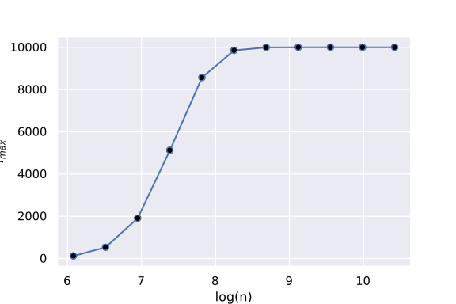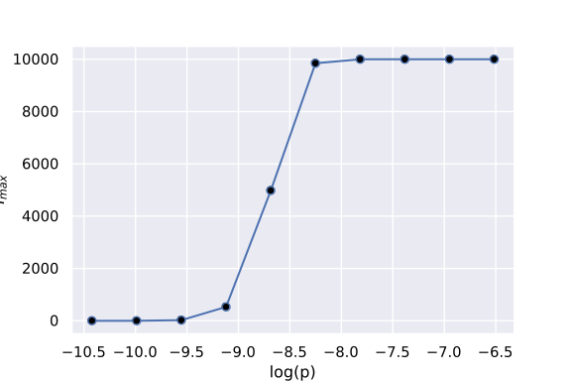

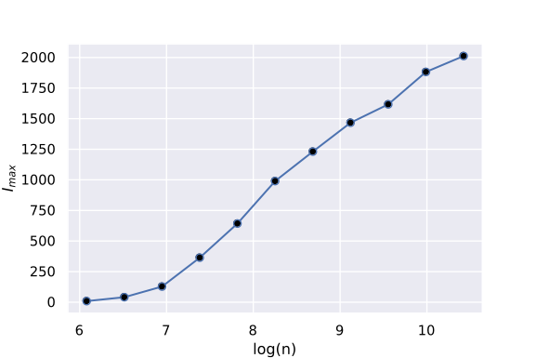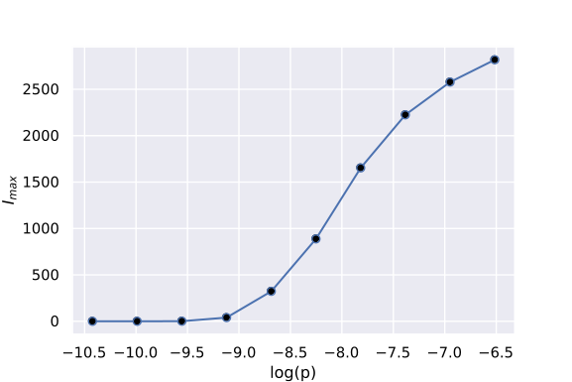Fig 4: Maximum cumulative incidence from the context-independent (top) and -dependent (bottom) models, against log(p) (right) and log(n) (left). As opposed to the context-independent model that only reaches saturation at 100% incidence, the context-dependent model produces a more realistic relationship between maximum cumulative incidence, and ‘p’ and ‘n’.

Testing predictions of the three models:

1. total incidence in the realistic range?
2. age incidence pattern
3. relationship with cell number,
4. relationship with mutation rates
5. explaining non-mutagenic carcinogens
6. Peto’s paradox and other paradoxes.

Compatibility with branched evolution, polyclonality, clonal synergies: We used a linear evolution model for examining the predictions of context independent and context-dependent selection. The models can incorporate branched evolution, polyclonality or clonal synergies. But this incorporation does not change the mainstream predictions of the models.

Implications for cancer control: Identifying the microenvironmental factors that influence the selection dynamics and studying their regulation should be the main focus of translational cancer research. If we can maintain a microenvironment that gives a selective advantage to the normal cell over an intermediate pre-cancer mutant, cancer is unlikely to develop. By this strategy cancer should be largely preventable.

**References:**

1. Behe, M.J., and Snoke, D.W. Simulating evolution by gene duplication of protein features that require multiple amino acid residues. Protein Sci. (2004). *13*, 2651–2664.
2. Johnson, P.E., and Behe, M.J. Darwin on trial (InterVarsity Press). (2010).
3. Borel, É. La mécanique statique et l’irréversibilité. J Phys Theor Appl (1913). *3*, 189–196.
4. Dawkins, R. The blind watchmaker: Why the evidence of evolution reveals a universe without design (WW Norton & Company). (1986).
5. Schäfer, M., and Werner, S. Cancer as an overhealing wound: an old hypothesis revisited. Nat. Rev. Mol. Cell Biol. (2008). *9*, 628–638.
6. Caulin, A.F., and Maley, C.C. Peto’s Paradox: evolution’s prescription for cancer prevention. Trends Ecol. Evol. (2011). *26*, 175–182.
7. Caulin, A.F., Graham, T.A., Wang, L.-S., and Maley, C.C. Solutions to Peto’s paradox revealed by mathematical modelling and cross-species cancer gene analysis. Phil Trans R Soc B (2015). *370*, 20140222.
8. Nagy, J.D., Victor, E.M., and Cropper, J.H. Why don’t all whales have cancer? A novel hypothesis resolving Peto’s paradox. Integr. Comp. Biol. (2007). *47*, 317–328.
9. Roche, B., Hochberg, M.E., Caulin, A.F., Maley, C.C., Gatenby, R.A., Misse, D., and Thomas, F. Natural resistance to cancers: a Darwinian hypothesis to explain Peto’s paradox. Bmc Cancer (2012). *12*, 387.
10. Klapper, L.N., Kirschbaum, M.H., Sela, M., and Yarden, Y. Bio chemical and clinical implications of the ErbB/HER signaling network of growth factors. Adv Cancer Res (2000). *77*, 25–78.
11. Mendelsohn, J., and Baselga, J. The EGF receptor family as targets for cancer therapy. Oncogene (2000). *19*, 6550–6565.
12. Olayioye, M.A., Neve, R.M., Lane, H.A., and Hynes, N.E. The ErbB signaling network: receptor heterodimerization in development and cancer. EMBO J. (2000). *19*, 3159–3167.
13. Witsch, E., Sela, M., and Yarden, Y. Roles for Growth Factors in Cancer Progression. Physiol. Bethesda Md (2010). *25*, 85–101.
14. Zhang, X., and Chang, A. Somatic mutations of the epidermal growth factor receptor and non‐small‐cell lung cancer. J. Med. Genet. (2007). *44*, 166–172.
15. Lemmon, M.A., and Schlessinger, J. Regulation of signal transduction and signal diversity by receptor oligomerization. Trends Biochem. Sci. (1994). *19*, 459–463.
16. Yu, J., Liu, X.-W., and Kim, H.-R.C. Platelet-derived growth factor (PDGF) receptor-α-activated c-Jun NH2-terminal kinase-1 is critical for PDGF-induced p21WAF1/CIP1 promoter activity independent of p53. J. Biol. Chem. (2003). *278*, 49582–49588.
17. Reis-Filho, J.S., Steele, D., Di Palma, S., Jones, R.L., Savage, K., James, M., Milanezi, F., Schmitt, F.C., and Ashworth, A. Distribution and significance of nerve growth factor receptor (NGFR/p75NTR) in normal, benign and malignant breast tissue. Mod. Pathol. (2006). *19*, 307–319.
18. Tsang, J.Y., Wong, K.H., Lai, M.W., Lacambra, M.D., Ko, C.-W., Chan, S.K., Lam, C.C., Alex, M., Tan, P.-H., and Gary, M.T. Nerve growth factor receptor (NGFR): a potential marker for specific molecular subtypes of breast cancer. J. Clin. Pathol. jclinpath (2012)..
19. Ahmad, I., Iwata, T., and Leung, H.Y. Mechanisms of FGFR-mediated carcinogenesis. Biochim. Biophys. Acta BBA-Mol. Cell Res. (2012). *1823*, 850–860.
20. Katoh, M., and Nakagama, H. FGF receptors: cancer biology and therapeutics. Med. Res. Rev. (2014). *34*, 280–300.
21. Koziczak, M., Holbro, T., and Hynes, N.E. Blocking of FGFR signaling inhibits breast cancer cell proliferation through downregulation of D-type cyclins. Oncogene (2004). *23*, 3501–3508.
22. Goel, H.L., and Mercurio, A.M. VEGF targets the tumour cell. Nat. Rev. Cancer (2013). *13*, 871–882.
23. Nexø, E., Hollenberg, M.D., and Bing, J. Aggressive behaviour in mice provokes a marked increase in both plasma epidermal growth factor and renin. Acta Physiol. Scand. (1981). *111*, 367–371.
24. Nexø, E., Olsen, P.S., and Poulsen, K. Exocrine and endocrine secretion of renin and epidermal growth factor from the mouse submandibular glands. Regul. Pept. (1984). *8*, 327–334.
25. Roberts, M.L. Testosterone-induced accumulation of epidermal growth factor in the submandibular salivary glands of mice, assessed by radioimmunoassay. Biochem. Pharmacol. (1974). *23*, 3305–3308.
26. Davison, J., Befus, A., and Mathison, R. The cervical sympathetic trunk—submandibular gland neuro-endocrine axis: its role in immune regulation. Biomed Res (2003). *14*, 30–37.
27. Aloe, L., Bracci-Laudiero, L., Alleva, E., Lambiase, A., Micera, A., and Tirassa, P. Emotional stress induced by parachute jumping enhances blood nerve growth factor levels and the distribution of nerve growth factor receptors in lymphocytes. Proc. Natl. Acad. Sci. (1994). *91*, 10440–10444.
28. Wilson, S.E., Chen, L., Mohan, R.R., Liang, Q., and Liu, J. Expression of HGF, KGF, EGF and receptor messenger RNAs following corneal epithelial wounding. Exp. Eye Res. (1999). *68*, 377–397.
29. Berker, B., Emral, R., Demirel, C., Corapcioglu, D., Unlu, C., and Kose, K. Increased insulin-like growth factor-I levels in women with polycystic ovary syndrome, and beneficial effects of metformin therapy. Gynecol. Endocrinol. (2004). *19*, 125–133.
30. Bulló, M., Peeraully, M.R., Trayhurn, P., Folch, J., and Salas-Salvadó, J. Circulating nerve growth factor levels in relation to obesity and the metabolic syndrome in women. Eur. J. Endocrinol. (2007). *157*, 303–310.
31. Mraz, M., Bartlova, M., Lacinova, Z., Michalsky, D., Kasalicky, M., Haluzikova, D., Matoulek, M., Dostalova, I., Humenanska, V., and Haluzik, M. Serum concentrations and tissue expression of a novel endocrine regulator fibroblast growth factor‐21 in patients with type 2 diabetes and obesity. Clin. Endocrinol. (Oxf.) (2009). *71*, 369–375.
32. Rasmussen, M., Hvidberg, A., Juul, A., Main, K., Gotfredsen, A., Skakkebaek, N., Hilsted, J., and Skakkebae, N. Massive weight loss restores 24-hour growth hormone release profiles and serum insulin-like growth factor-I levels in obese subjects. J. Clin. Endocrinol. Metab. (1995). *80*, 1407–1415.
33. Morrison, S.J., Shah, N.M., and Anderson, D.J. Regulatory Mechanisms in Stem Cell Biology. Cell (1997). *88*, 287–298.
34. Reya, T., Morrison, S.J., Clarke, M.F., and Weissman, I.L. Stem cells, cancer, and cancer stem cells. Nature (2001). *414*, 105–111.
35. Sasaki, T., Hiroki, K., and Yamashita, Y. The Role of Epidermal Growth Factor Receptor in Cancer Metastasis and Microenvironment. BioMed Res. Int. (2013). *2013*, 546318.
36. Coutu, D.L., and Galipeau, J. Roles of FGF signaling in stem cell self-renewal, senescence and aging. Aging (2011). *3*, 920–933.
37. Discher, D.E., Mooney, D.J., and Zandstra, P.W. Growth factors, matrices, and forces combine and control stem cells. Science (2009). *324*, 1673–1677.
38. Shi, Y., Sun, G., Zhao, C., and Stewart, R. Neural Stem Cell Self-renewal. Crit. Rev. Oncol. Hematol. (2008). *65*, 43–53.
39. Tomellini, E., Touil, Y., Lagadec, C., Julien, S., Ostyn, P., Ziental-Gelus, N., Meignan, S., Lengrand, J., Adriaenssens, E., and Polakowska, R. Nerve Growth Factor and proNGF Simultaneously Promote Symmetric Self-Renewal, Quiescence, and Epithelial to Mesenchymal Transition to Enlarge the Breast Cancer Stem Cell Compartment. Stem Cells (2015). *33*, 342–353.
40. González-Suárez, E., Samper, E., Ramírez, A., Flores, J.M., Martín-Caballero, J., Jorcano, J.L., and Blasco, M.A. Increased epidermal tumors and increased skin wound healing in transgenic mice overexpressing the catalytic subunit of telomerase, mTERT, in basal keratinocytes. EMBO J. (2001). *20*, 2619–2630.
41. Osanai, M., Tamaki, T., Yonekawa, M., Kawamura, A., and Sawada, N. Transient increase in telomerase activity of proliferating fibroblasts and endothelial cells in granulation tissue of the human skin. Wound Repair Regen. (2002). *10*, 59–66.
42. Hunt TK, Conolly WB, Aronson SB, Goldstein P Anaerobic metabolism and wound healing: an hypothesis for the initiation and cessation of collagen synthesis in wounds. Am J Surg. (1978). 135 (3):328-32.
43. Hunt, T.K. The physiology of wound healing. Ann. Emerg. Med. (1988). *17*, 1265–1273.
44. Gurtner, G.C., Werner, S., Barrandon, Y., and Longaker, M.T. Wound repair and regeneration. Nature (2008). *453*, 314–321.
45. Tonnesen, M.G., Feng, X., and Clark, R.A. Angiogenesis in wound healing. (Nature Publishing Group), (2000). pp. 40–46.
46. Mardin, B.R., Isokane, M., Cosenza, M.R., Krämer, A., Ellenberg, J., Fry, A.M., and Schiebel, E. EGF-induced centrosome separation promotes mitotic progression and cell survival. Dev. Cell (2013). *25*, 229–240.
47. Schrevel, M., Gorter, A., Kolkman-Uljee, S.M., Trimbos, J.B.M., Fleuren, G.J., and Jordanova, E.S. Molecular mechanisms of epidermal growth factor receptor overexpression in patients with cervical cancer. Mod. Pathol. (2011). *24*, 720–728.
48. Cao, L., Liu, X., Lin, E.-J.D., Wang, C., Choi, E.Y., Riban, V., Lin, B., and During, M.J. Environmental and Genetic Activation of a Brain-Adipocyte BDNF/Leptin Axis Causes Cancer Remission and Inhibition. Cell (2010). *142*, 52–64.
49. Eysenck, H.J. Cancer, personality and stress: Prediction and prevention. Adv. Behav. Res. Ther. (1994). *16*, 167–215.
50. Kavan, M.G., Engdahl, B.E., and Kay, S. Colon cancer: personality factors predictive of onset and stage of presentation. J. Psychosom. Res. (1995). *39*, 1031–1039.
51. Kune, G.A., Kune, S., Watson, L.F., and Bahnson, C.B. Personality as a risk factor in large bowel cancer: data from the Melbourne Colorectal Cancer Study. Psychol. Med. (1991). *21*, 29–41.
52. Eysenck, H.J. Personality, stress and cancer: prediction and prophylaxis. Br. J. Med. Psychol. (1988). *61*, 57–75.
53. Temoshok, L. Personality, coping style, emotion and cancer: towards an integrative model. Cancer Surv. (1986). *6*, 545–567.
54. Watve, M. Behavioral Deficiencies and Behavioral Supplementation. In Doves, Diplomats, and Diabetes, (Springer), (2013). pp. 305–317.